# **Enterprise Application Development 2023A**

# **Lab Test 1**

**Total marks: 30**

**Time: 3 days**

**Rules:**

1. Students can use Canvas and Internet for reference and other AI generator tools such as Copilot and ChatGPT. No discussion or exchange of ideas, external support is allowed.
2. Students put all the answer files into a folder, zip it and submit the zipped file.
3. Sharing or disclosing lab test questions to forums, Q&A platforms are prohibited.
4. Students should make their own assumptions based on common sense. Please don’t ask questions that are straightforward as it can slow down your progress.

**Question 1 (15 marks). Build a quiz system using html, css, and javascript**

Students can use any html, css, or javascript framework to do this question. Students use localStorage to store the quizzes and its content. Users can reload the quiz even if they close and restart the browser.

<https://developer.mozilla.org/en-US/docs/Web/API/Web_Storage_API>

The system should allow view/add/update/delete quiz questions and answers.

A quiz can include 1 to 100 questions. Each question can be multiple choice, short answer, or matching. Each question will have points, i.e. 1, 2, 4 points. A quiz will have total points.

* Multiple choice: can have 1-10 choices. One or many choices can be correct answers
* Short answer: provide textarea for users to answer.
* Matching: a list of statements in group A and a list of statements in group B.

The system must have 2 modes: quiz edit mode (for teacher) and quiz taking mode (for students)

Suggestions of screens can be from Canvas.

**List of quiz**

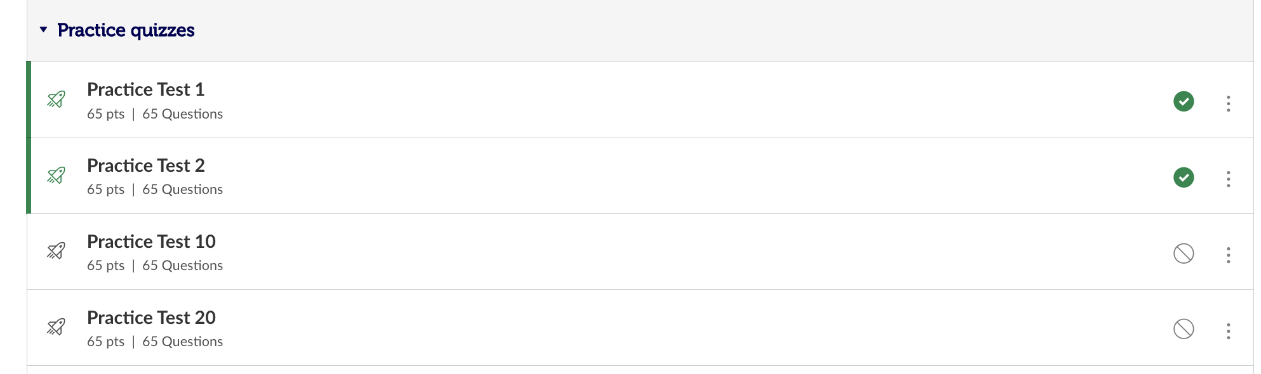

**Quiz edit form**

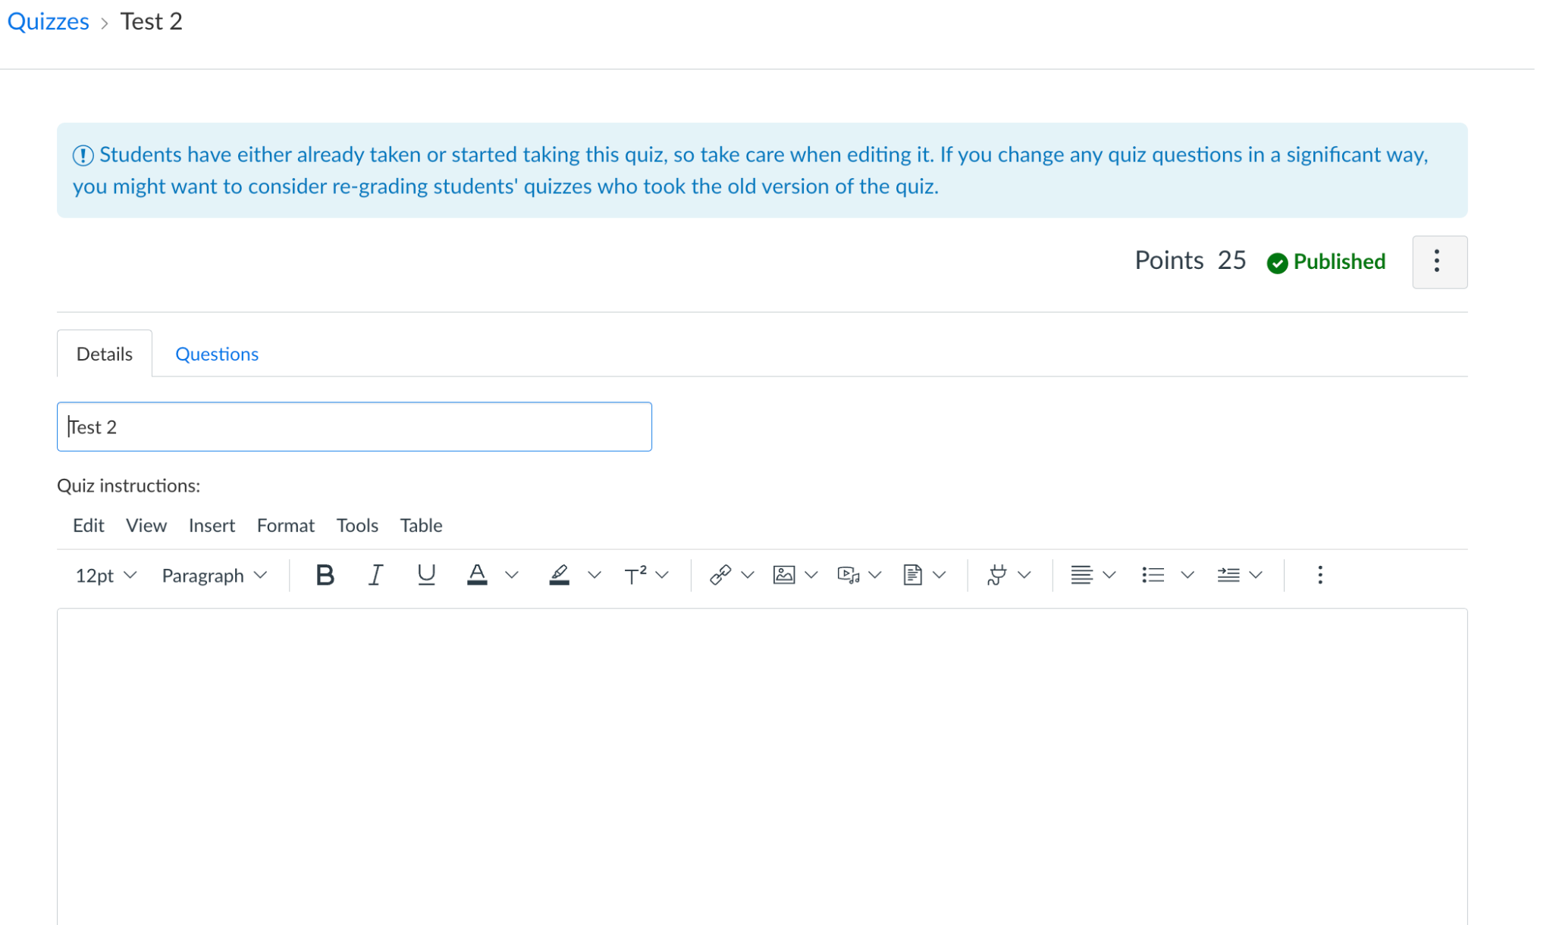

1. ***Multiple choice questions edit form***

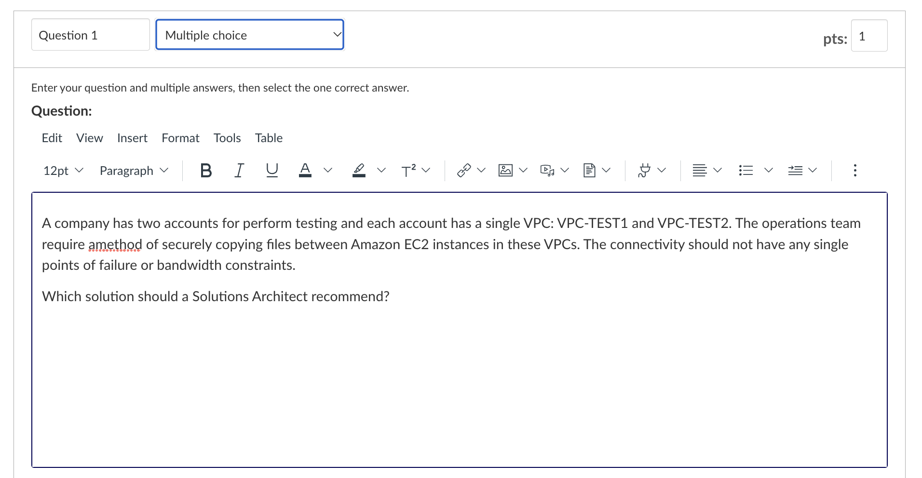

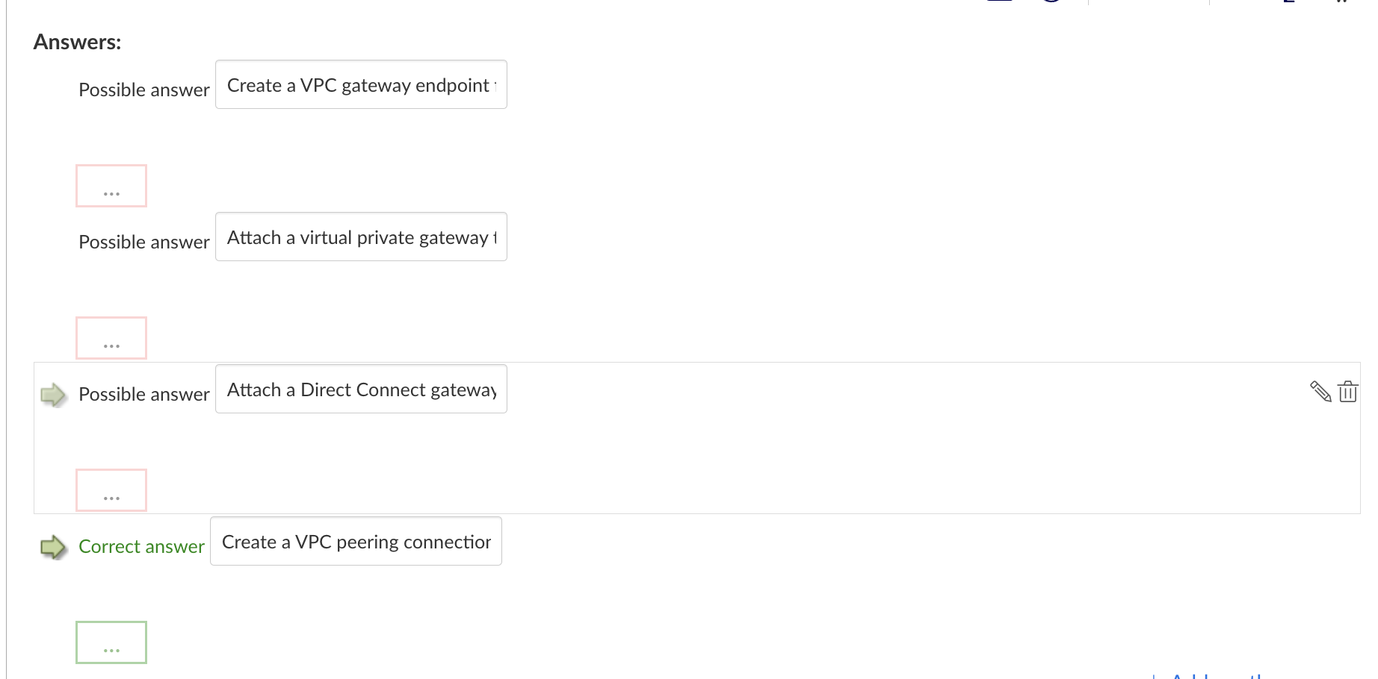

1. ***Short answer question form:***

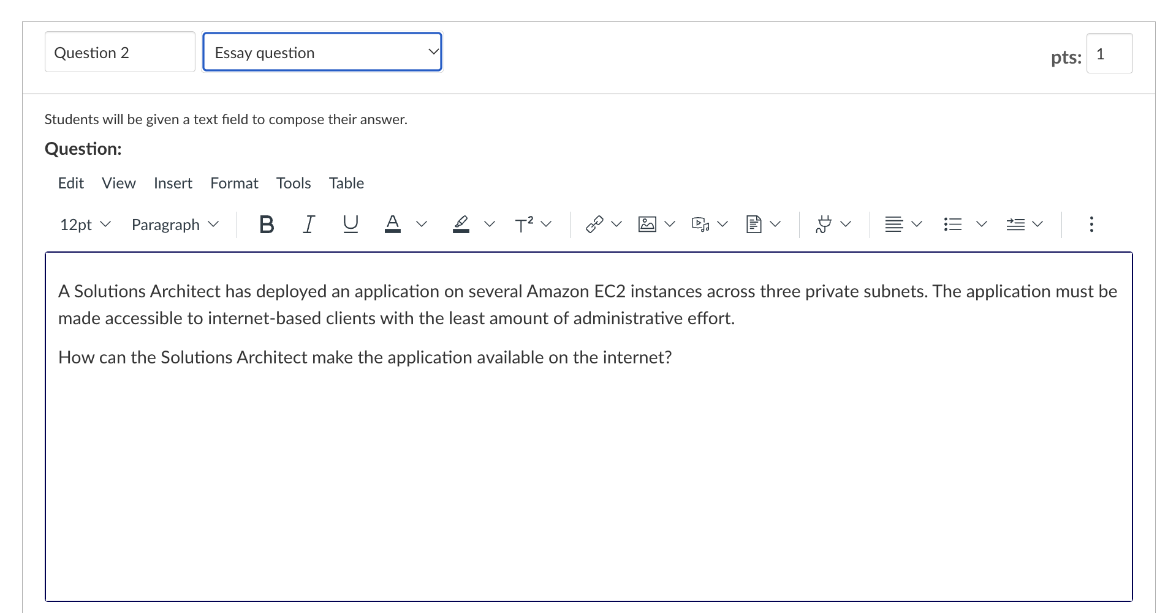

1. ***Matching questions***

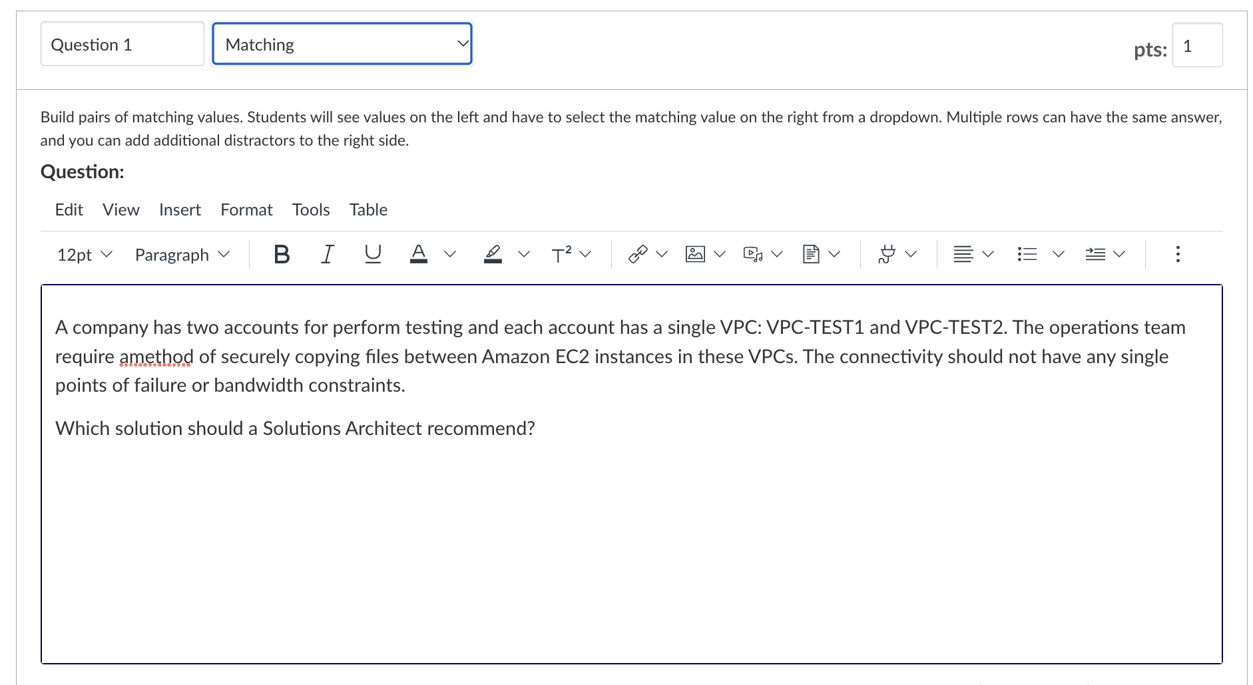

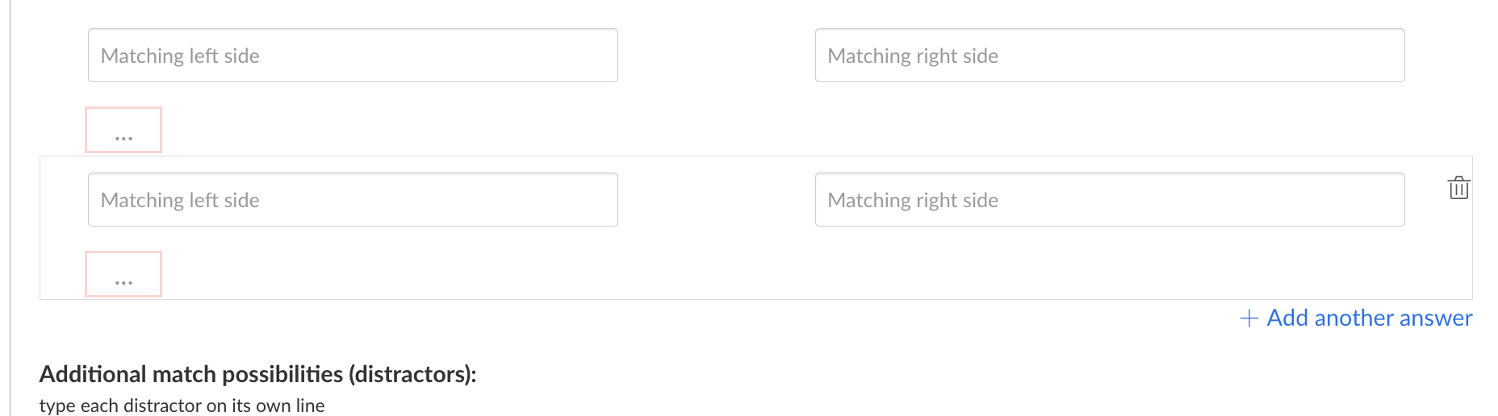

**Question 2 (15 marks). REST API and frontend**

Build a system that consumes a public API. The system can be anything depending on the public API students select. Student can build a weather app for traveler:

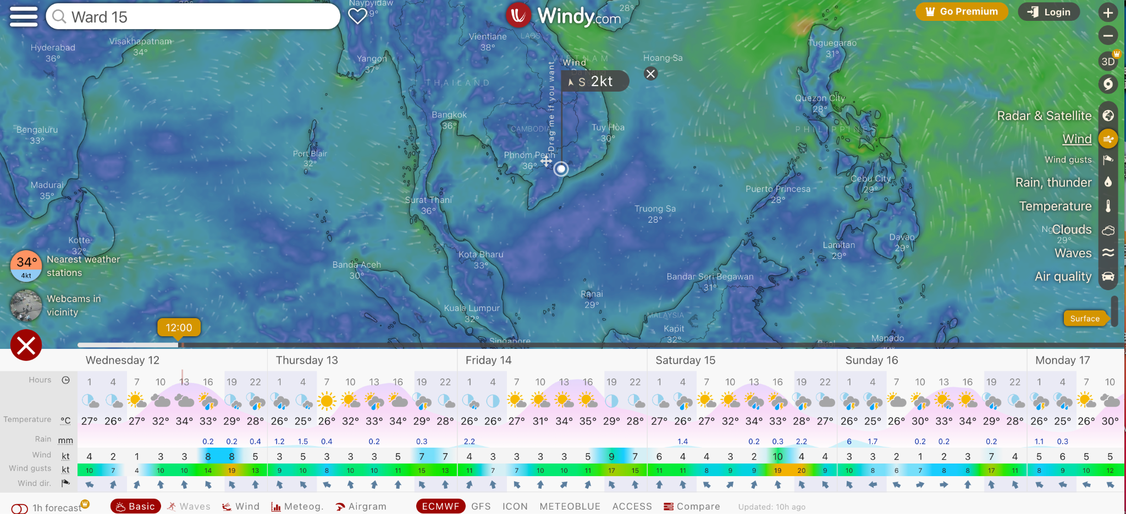

Or an app to view universe using NASA API:



**Marking criteria:**

* Interesting and innovative idea
* Level of completion of the app, i.e. providing enough functionality to view, search, filter, present data in different ways (table, image, graph)
* Allow dynamic interaction with the app, i.e. render or change view based on users click or scrolling
* Big data processing should be paged to reduce the load for web browsers.
* Students can use ChatGPT and Copilot to support their work but significant modifications and personal efforts must be made in order to get high marks.
* Exchanging work and downloading code from github and other online repositories, sample tutorials and then do some modification is prohibited. Code will be crossed between students' work and online repos to find similarity.

Here are some examples of common public APIs that are available for developers to use:

OpenWeatherMap API: Provides weather data for cities and regions around the world, including current conditions, forecasts, and historical data.

Twitter API: Allows developers to interact with the Twitter platform, including accessing user data, posting and retrieving tweets, and searching for content.

GitHub API: Provides programmatic access to GitHub repositories, issues, and other data, enabling developers to build integrations with GitHub and automate tasks.

Google Maps API: Enables developers to integrate Google Maps into their web applications, including adding markers, overlays, and other features, as well as accessing location data and directions.

Spotify API: Provides programmatic access to the Spotify music platform, including user data, playlists, and metadata about songs and artists.

YouTube API: Allows developers to interact with the YouTube platform, including uploading and retrieving videos, managing playlists, and accessing analytics data.

Stripe API: Enables developers to integrate payment processing into their web applications, including processing payments, managing subscriptions, and handling refunds.

Twilio API: Provides a range of communication services, including SMS and voice messaging, two-factor authentication, and video calls, enabling developers to build communication features into their applications.

Flickr API: Allows developers to access the Flickr photo-sharing platform, including searching for photos, retrieving user data, and uploading images.

NASA API: Provides access to a range of data and imagery from NASA, including satellite imagery, astronomical data, and scientific research data.

End of the test